**Hotel Management System**

**Software Requirements Specification**

**Document**

**Prepared by**

* **Hussien Ibrahiem Abo-alhassan**
* **Sarah Ahmed Shawky Mohammed**
* **Doha Samy Abd-Elnabi**
* **Shehab Mansour Tolba**
* **Yassmin Samir Awad Ibrahim**
* **Hussein Abd-Elateef Hussein**

**Version: (1.2)** **Date: (18/12/2016)**

**Table of Contents**

**1 Introduction**

1.1 Purpose………………………………………………………………………………………………… 3

1.2 Scope of the project. ……………………………………………………………………………………3

**2 Feasibility Study**…………………………………………………………………………………… 4

**3 Interview**…………………………...…………………………………………………………………....4

**4 Specific Requirements**

**4.1 User requirement**………………………………….……………………………………………….6

4.1.1 User requirement for website ………………………….…………………………………………… 6

4.1.2 User requirement for desktop system…………………………………………………………………6

**4.2 System Requirement**

4.2.1 System requirement for website……………………………………………………………………...7

4.2.2 System requirement for desktop system…………………………………………………………… 13

**4.3 Non functional Requirement**

4.3.1 Performance………………………………………………………………………………………… ...21

4.3.2 Availability ………………………………………………………………………,……………………21

4.3.3 Security………………………………………………………………………………………………...21

4.3.4 Maintainability…………………………………………………………………………………………21

4.3.5 Portability……………………………………………………………………………………………,,.21

**5 Models**

5.1 Use case diagram………………………………………………………………………………………….22

5.2sequence diagrams.........................................................................................................................................23

5.3Activity diagrams...........................................................................................................................................27

5.4Class diagrams..............................................................................................................................................28

5.5state diagrams............................................................................................................................................29

Introduction

This Software Requirement Specification document provides a complete description of all the functionalities and the specifications of the Hotel Management System.

## Purpose :

## This document will represent a detailed hotel management system. It will present the system functional and non-functional requirements ,how the functional and non-functional requirements will be achieved in the website and desktop system ,the system interface, what the system will do and the constraints. The main goal of this project is to design a system that will compete with other hotel management system.

## Scope of the Project :

The software to be produced is a Hotel Management System. The website ,which will help the customers to reserve rooms and other facilities of the hotel from anywhere in the world. The desktop system, which will be accessed by the manager and the receptionist. The hotel website provides a solution regarding the hotel reservation problems of users. The user can easily check the availability of the room and if the room is available , then he/she can get a room in the hotel. By the use of the internet, the user can save so much time for his reservation .There are two end users for hotel management system. The end users are manager and receptionist.

Manager can access to all system functionalities without any restrictions :

* add/update guest information
* add/delete offers
* control meal items and prices
* provide offers in the hotel.

receptionist can access to the reservation system section and some other functionalities:

* display room information
* check out and generate bill
* provide room service.

The reservation System is for reserving room and conference and check availability. The customer can book the rooms through online or through in-person. The newly introduced system will provide an easy access to the system and it will contain user-friendly functions with attractive interfaces. The final outcome of this project will increase the efficiency of almost all the tasks done at the hotel .

**Feasibility study**

We have studied the proposed project and the results of our work .we have also studied

the dangers that will meet us ,identified targets for the project and the constraints under

which it must operate and how the system will react to external stimuli ,then we have

decided to complete the project

**Interview**

We have conducted an interview with Elwatnya hotel and these are the questions and the answers :

**1.What are the services provided by the system to the administration staff?**

Services provided by the system:

-add customer

-remove account

-edit account

-search customer

-check out

-check in

-room service

-generate bill

-register conference rooms

-booking

-cancel booking

-edit booking

-modify booking

-room information

-conference room services

-billing reports

**2- What are the services provided by the website to the customer?**

-searching for rooms

-booking

-cancel booking

-offers

-hotel information(place , pictures , web links)

**3. Who are the people who can deal with the system ?**

receptionist, the hotel manager

**4. What information is needed by the system to complete the process of booking?**

Information needed : a person full name ,a copy of National ,phone number, Identity card / passport , how long they would stay and the room system.

**5. what are the offers that can be provided by the hotel?**

Offers and discounts depend on the need of the hotel

if the booking is few ,it provides offers as:

1-there will be a discount in a particular month.

2-if the customer has reserved a month then the system will offer him 3 days discount .

**6. What is the meals system?**

Meal Plan: The breakfast is from 6:am is to 10:am , lunch and dinner are optional

**7. Is there an Internet service?**

Internet service are available in which Each room has a username and password .

**Specific Requirements**

## User Requirements.

## Functional Requirements

**1 . Site**

**1.1.The site shall provide booking room via internet.**

**1.2.The site shall show offers in hotel.**

**1.3.The site shall show information about hotel.**

**1.4.The site shall provide cancel booking room via internet.**

**1.5.The site should provide check availability of conference rooms in specific days**

**1.6.The site shall provide booking conference room via internet.**

**1.7.The site shall provide cancel booking conference room via internet.**

**1.8.The site should provide check availability of rooms in specific period.**

**2 . Desktop System**

**2.1.The system shall provide Login into the system as Manager or receptionist (Front Office).**

**2.2.The system shall provide (Add , Confirm , edit , cancel ) Booking room in the hotel .**

**2.3.The system shall provide (Add , Confirm , edit , cancel ) Booking conference room in the**

**hotel**

**2.4.The system shall allow searching and update Guests Information**

**2.5.The system shall check out Guest and generate bill.**

**2.6.The system shall display room information .**

**2.7.The system shall provide Room Service / Restaurant.**

**2.8.The system shall record the Guest feedback.**

**2.9.The system shall send Hotel offers to Guests e-mail.**

**2.10.The system shall allow managers to Create , modify , delete meal items and prices.**

**2.11.The system shall allow managers to modify Rate for Normal Rooms and conference rooms**

**2.12.The system shall allow managers to add and delete Hotel offers .**

**Site system requirement**

|  |  |
| --- | --- |
| **The site shall provide booking via the internet** | |
| Function | Reservation/Booking |
| Description | Booking a room in the hotel and record customer information |
| Input | Full Name ( text),Gender ( Male or Female ),Address ( text), City (text). Nationality(text) ,Mobile ( number).Email(text), national ID ( number ).  Check-In Date, Expected Check-Out Date, With lunch or not , |
| Source | Read data from user |
| Output | confirm booking and room number |
| Destination | Booking page , database |
| Action | user check the availability of room which he/she wants to reserve then he can book after checking .if it is available ,book button will appear, if not he can’t book . User press the booking button and fill registration document and input Full Name ( text),Gender ( Male or Female ),Address ( text), City (text). Nationality(text) ,Mobile ( number),Email(text),national ID ( number ).  if he did not fill all records in the registration form ,the site will respond and open the form again to fill all records. otherwise a room will be reserved in the database then display message with room number and total money , then inform guest that he must send 10% of money to hotel by Vodafone cash or fawry and tell him the number of hotel in Vodafone and if he not send money before 1 days from check in date reservation will be cancel automatic by system. |
| Requirement | check availability |
| Pre-condition | all data are correct and the user fills all records. |
| Post-condition | Chosen room will be reserved in the database. |

|  |  |
| --- | --- |
| The site shall show offers in the hotel | |
| Function | Show hotel offers |
| Description | Hotel present offers every period of time that will be displayed on the site |
| Input | Database |
| Source | database |
| Output | display offers in a slider on the home page. |
| Destination | home page background |
| Action | The user will visit the site to see offers displayed on the site at this time .  if the user want to use an offer , he will choose it and confirm his registration. |
| Requirement | Manager add hotel offers |
| Pre-condition | exist offers |
| Post-condition | All offers are displayed in home page |

|  |  |
| --- | --- |
| The site shall show information about the hotel | |
| Function | Information about the hotel |
| Description | All information about the hotel is in "about us" icon |
| Input | Press on “ about us” icon or on social media icon |
| Source | user , database admin |
| Output | If the user presses on social media icon , it will open the hotel account. if the user presses on about us interface ,it will show the hotel address and all contact numbers . |
| Destination | “about us” icon |
| Action | In header interface, there exist an “about us” icon. if the user presses on it, it will go to footer and display hotel address , telephone number , social icons of facebook , askfm , Gmail and twitter accounts . the room photos and information will be displayed on the home page . |
|  |  |
| Requirement | None. |
| Pre-condition | None. |
| Post-condition | None. |

|  |  |
| --- | --- |
| The site shall provide cancel booking room via the internet | |
| Function | Cancel Reservation/Booking |
| Description | Cancel Booking a room in the hotel will delete customer information and reservation. |
| Input | Id (number) , room number(number). |
| Source | Read data from user |
| Output | Display to the user if the reservation is canceled or not |
| Destination | Booking page, database |
| Action | User presses on canceling button then enter id number and room number. canceling shall not be less than one day before check in date, then the reservation will be canceled . if there is no id national number , room number or id and room number not belong to each other, the site will display a message to enter correct data. |
| Requirement | None. |
| Pre-condition | Exist reservation |
| Post-condition | The room change from occupied to free in database if it exist |

|  |  |
| --- | --- |
| The site should provide check availability of rooms in specific period. | |
| Function | search the availability of a specific room |
| Description | Function to check the availability of a specific room |
| Input | check in date (day”number ” , month,year”text ”) check out (day”number ” , month,year”text ”) |
| Source | customer and database |
| Output | display availability of rooms at that time |
| Destination | homepage |
| Action | In the home page ,user will input check in data ,check out data ,and the number of rooms available (note that all the rooms in the hotel are single rooms).then the user presses check availability ,the system will respond if the room is available at this time or not |
| Requirement | None. |
| Pre-condition | None. |
| Post-condition | None |

|  |  |
| --- | --- |
| **The site should provide booking conference hall** | |
| Function | Booking Conference hall |
| Description | Booking conference hall in hotel for meetings |
| Input | Full Name ( text).,Gender ( Male or Female ),Address ( text), City (text). Nationality(txt) ,Mobile ( number).Email ( text).ID ( number ).  Check in date. |
| Source | User |
| Output | Display the date conference hall will be available and default price |
| Destination | Data base |
| Action | user checks the available days for booking conference hall , then he will complete his/her information by choosing the meal system .if he/she wants launch and drink or not then submit. if the user didn't fill all the records, the site will ask him to fill the empty records. if the user completes the form , then the total money will be displayed on a message and inform him/her that he/she must send 10% of the money to the hotel by Vodafone cash or fawry. It will tell display the Vodafone number of the hotel. if he did not send money before 1 day from c heck in date, reservation will be canceled automatically by system. |
| Requirement | check availability |
| Pre-condition | None. |
| Post-condition | Assign a conference room at this date as occupied in the database |

|  |  |
| --- | --- |
| **The site shall provide cancel booking conference hall via internet** | |
| Function | Cancel Reservation/Booking |
| Description | Cancel Booking conference hall in the hotel will delete reservation. |
| Input | Id number(number) , check in date (text) |
| Source | Read data from user |
| Output | Display to the user if the reservation is canceled or not |
| Destination | Homepage, database |
| Action | User presses cancelling button and enter id number, check in date and canceling shouldn't be less than one day before check in date. then the reservation will be canceled. if there is no id number reserved at this time, the site will display a message that this id hasn't confirmed in the hotel |
| Requirement | None. |
| Pre-condition | exist reservation in database |
| Post-condition | The conference hall change from occupied to free in database |

|  |  |
| --- | --- |
| The site should provide check availability of a conference hall in a specific period. | |
| Function | search availability of specific room |
| Description | Function to check availability of a specific conference hall |
| Input | check in date (text). |
| Source | user and database |
| Output | display the availability of a specific conference hall at this time. |
| Destination | homepage |
| Action | in the homepage, a user will input check in date then press check availability. The system will respond if the conference hall is available at this time or not.if yes, it will display a book button .if not ,it will message him that not available |
| Requirement | None. |
| Pre-condition | None. |
| Post-condition | None |

**Desktop system requirement**

|  |  |
| --- | --- |
| **The system shall provide Login into the system as Manager or receptionist (Front Office).** | |
| Function | Login |
| Description | Login function to allow user or manager to enter to the system. |
| Input | Username (Text contain letters only). Password (Text contains digits , letters and symbols). |
| Source | User |
| Output | Open the main page of the system or display message re-enter correct username, password. |
| Destination | Main page of the system |
| Action | When a user opens the system, it will ask the user to write username and password.  When a user writes password, the password is hidden automatically by the system like (****).  If user doesn’t write username or password,a message will be displayed to enter it.  If username or password are not correct ,a message will be displayed to the user to re-enter.  If username and password are valid , it will open the main page of the system. |
| Requirement | None. |
| Pre-condition | Username and password are exist. |
| Post-condition | Display main page of system . |

|  |  |
| --- | --- |
| **The system shall provide (Add , Confirm , edit , cancel ) Booking in the hotel** | |
| Function | Room Booking / Reservation. |
| Description | This Function is for Booking a Room in the hotel or to Confirm existing reservation room or to Edit existing reservation or Cancel existing reservation. |
| Input | **If Add Reservation :**  Full Name ( text),Gender ( Male or Female ),Address ( text), City (text). Nationality(txt) ,Mobile ( number).Email(text).ID ( number ).  Check-in date, Expected check-out date, With lunch or not ,  Room number (default first Available room).  **if Confirm Reservation :**  Full Name (text),ID (number).  **If Edit or Cancel:**  Room number ( number). |
| Source | Read From User. |
| Output | Display Done For Add Reservation or Done for Confirm Reservation or Edit or Cancel.  Display Not Valid if any Of information is not correct. |
| Destination | store Information in Database System. |
| Action | There Will be Button (room Booking) That when a user presses on it, he Will Choose between  Add or Edit , Confirm or Cancel Reservation .  **If he/she chooses Add :**  The system will allow a user to enter all information that is needed to reserve a room .before writing Guest Information, he can search for his/her information by writing its ID .if the system finds this guest information, it will allow the user to write other information needed only like ( check-in date , expected check-out date, Room Number). Otherwise, the system will allow the user to enter all information about guest , other information and then presses submit.  if any of this information are not correct, it will display a message to Re-enter this information. Otherwise, it will display a Message Done and go back to the main page.  **If he/she chooses Confirm :**  The system will allow the the user to enter Full name and ID. if this is not correct, it will display a message to re-enter correct full name and id. otherwise, it will Confirm This Reservation.  **If he/she chooses Edit :**  The system will allow a user to enter Full name and ID. if this is not correct, it will display a message to re-enter correct full name and id. otherwise, it will show all Information about this Reservation and can edit check-out date only then presses save.  **If he/she chooses cancel :**  The system will allow the user to enter Full name and ID. if this is not correct, it will display a message to re-enter correct full name and id then check if check –in-date of this reservation is after 1 days or not. if after 1 day, it will Cancel This Reservation. otherwise, it Can`t cancel.  Then if User press on button Back to the main page of the system , it will go back to the main page. |
| Requirement | Login to the System |
| Pre-condition | None. |
| Post-condition | Add or Remove or Update data in database and display to the user that is Done .. |

|  |  |
| --- | --- |
| **The system shall allow searching and update Guests Information** | |
| Function | Searching Guest |
| Description | Allow the user to search for guest or update existing guest. |
| Input | Full Name (text),ID (number). |
| Source | Read from user. |
| Output | Display Not Found if this guest is not found or display guest information . |
| Destination | Main page of the system |
| Action | When a user presses on Button Search, the system will ask the user to write full name and ID number then presses Button Search .  If User did not Write Name or ID, a message will be displayed to enter it.  If Name or ID is not Found on the Database, the system will display "Not Found this Guest ".  Otherwise, it will display information about this guest and allow user to edit it.  Then he/she presses Save and the system will display a message done.  Then if User press in button Back to Main Page of system will back to main page. |
| Requirement | Login to system |
| Pre-condition | Guest found in database |
| Post-condition | Update Data in database then Back to Main Page of system . |

|  |  |
| --- | --- |
| **The system shall check out Guest and generate bill** | |
| Function | Check Out |
| Description | Check out guest and after this generate bill. |
| Input | Room number or Guest Name |
| Source | Read from user. |
| Output | Display bill and information about this bill |
| Destination | Main Page of System , Database |
| Action | When a user presses on check out button, the system will allow the user to enter Room number or guest name then search for this room. if this room is not occupied or the guest name wasn’t found, it will display message re-enter valid room number or guest name.  Otherwise, it will generate the bill , display it and its details.  Then if User presses on button Back, the system will go back to the main page. |
| Requirement | Login to system |
| Pre-condition | Room is Found and occupied . |
| Post-condition | Make this room available and change this in database then go back to the main page. |

|  |  |
| --- | --- |
| **The system shall provide (Add , Confirm , edit , cancel ) Booking conference rooms in the hotel** | |
| Function | conference Booking / Reservation. |
| Description | This Function is for Adding/Booking conference Room in the hotel or to Confirm existing reservation conference room or to Edit existing reservation or Cancel existing reservation. |
| Input | **If he/she Adds Reservation :**  Full Name ( text),Gender ( Male or Female ),Address ( text), City (text). Nationality(txt) ,Mobile ( number).Email ( text).ID ( number ).  Number of days, date of every day  , conference Room Number (default first Available conference room).  **if he/she Confirms Reservation :**  Full Name (text),ID (number).  **If he/she Edit or Cancel:**  conference Room number ( number) or ( Name , ID(number) ). |
| Source | Reading From the user. |
| Output | Display Done For Add Reservation or Done for Confirm Reservation or Edit or Cancel.  Or Display Not Valid if any Of the information is not correct. |
| Destination | Put Information in the Database System. |
| Action | There Will be Button (conference Booking) That when user presses on in it , ihe/she Will Choose between  Add or Edit , Confirm or Cancel Reservation .  **If he/she chooses Add :**  System will allow the user to enter all information that are needed to reserve a conference room . Before writing Guest Information , he can search for his/her information by writing his/her ID. if the system finds the guest information , it will allow user to write other information needed only like ( number of date, date of every day, conference Room Number). Otherwise, the system will allow the user to enter all information about the guest, other information and then presses submit.  If any of this information are not correct, it will display a message to Re-enter this information. Otherwise, it will display Message Done and go back to the main page.  **If he/she chooses Confirm :**  The system will allow the user to enter Full name and ID. if this is not correct, it will display a message to re-enter correct full name and id. Otherwise, it will Confirm This Reservation.  **If he/she chooses Edit :**  The system will allow the user to enter Full name and ID .if this is not correct, it will display a message to re-enter correct full name and id .Otherwise, it will show all Information about this Reservation and can edit check-out date only then presses Save .  **If he/she chooses cancel :**  The system will allow user to enter full name and id .If this is not correct, it will display a message to re-enter correct full name and id then check if check –in-date of this reservation are after 1 days or not. If after 1 day, it will Cancel This Reservation .Otherwise, it Can`t cancel.  Then if the User presses on button Back to the main page , the system will go back to the main page. |
| Requirement | Login to the System |
| Pre-condition | The information needed are correct . |
| Post-condition | Add or Remove or Update Data in Database and display to the User that is Done |

|  |  |
| --- | --- |
| **The system shall display rooms information .** | |
| Function | Room information. |
| Description | Display room information (Number of available rooms and number of occupied rooms). |
| Input | None. |
| Source | Database. |
| Output | Display information of rooms |
| Destination | Main page of the system |
| Action | When a user login to the system, it will display room information in the main page of the system.  The number of rooms available, occupied, each room ( if it is occupied ) check in date and check out date and room number.. |
| Requirement | Login to the system |
| Pre-condition | None. |
| Post-condition | Display room information |

|  |  |
| --- | --- |
| **The system shall provide Room Service / Restaurant** | |
| Function | Room Service |
| Description | This function is for adding any service to the rooms and ordering anything from Restaurant to the room. |
| Input | Room Number .  Type of service ( meals , laundry , other services ).  If service meals :  Type , No. type  If service laundry :  Type , No. type |
| Source | Read from the user |
| Output | Display a message that is Done Added this service |
| Destination | Database |
| Action | When a user presses on button add service, the system will ask the user to enter room number , it must be valid room and occupied then choose service such as meal , laundry and type of meal or laundry and the number of this type that he/she can choose pizza after that chooses 2 then press save and the system will back to the main page of the system. |
| Requirement | Login to the system |
| Pre-condition | None. |
| Post-condition | Added this service to the room and update that in database then go back to the main page of the system |

|  |  |
| --- | --- |
| **The system shall record Guest feedback.** | |
| Function | Feedback |
| Description | Record Guest feedback |
| Input | Guest Full name(text) , Feedback(text) |
| Source | Read from user |
| Output | Display a message “ Done “saved in Database |
| Destination | Database |
| Action | When a user presses on the record guest feedback, the system will allow him to write the full name of the guest and his/her feedback then presses submit. After this, the system displays message Done and go back to the main page of the system. |
| Requirement | Login to the system |
| Pre-condition | None. |
| Post-condition | Add record to the database. |

|  |  |
| --- | --- |
| **The system shall send Hotel offers to the Guests e-mail** | |
| Function | Send Offers |
| Description | Send offers to Guests e-mail. |
| Input | None |
| Source | Database |
| Output | None. |
| Destination | Guests e-mails |
| Action | When manager add offers, the system automatically sends this offers to the guests e-mail. |
| Requirement | Add offers from manager |
| Pre-condition | There exist emails of guests. |
| Post-condition | Send offers to guests e-mails. |

|  |  |
| --- | --- |
| **system shall allow managers to Create , modify , delete meal items and prices** | |
| Function | Meals |
| Description | This function is allowed only to managers and can create modify , delete meal items |
| Input | If he/she needed to create :  Meal Name( text), price(number).  Ifhe/she needed to modify :  Meal Name(text) , new price(number), new name(text).  If he/she needed to delete:  Meal Name(text). |
| Source | Read from the user |
| Output | Message that is Done or not |
| Destination | Database. |
| Action | When User presses on button Meals, the system allows him/her to choose between Create Meal or Modify Meal or Delete Meal  If he/she chooses Create Meal :  The system will ask to write Meal Name and price of this Meal  and he/she must enter valid price .  Then he/she presses save and the system display done .if the user presses button back to main page, the system will go back to the main page.  If he/she chooses Modify Meal :  The system will ask to write Meal Name. if it is not found ,the system will display not found and allow the user to re-enter Meal name again or go back to the main page  Otherwise, it will display the meal name ,its price and allow user to modify Name and price.  Then press button save to save the meal name and price .  If he/she chooses Delete Meal:  The system will ask to write Meal Name. if it is not found, the system will display not found and allow user to re-enter Meal name again or go back to the main page.  Otherwise ,it will display that Meal is Deleted . |
| Requirement | Login to the system as a manager. |
| Pre-condition | If it is modified or deleted, the item must exist. |
| Post-condition | If he/she chooses Delete meal, the item will be deleted.  If he/she chooses create meal, the item will be added.  If he/she chooses modify meal, the item will modified.  Then Display the main page of the system . |

|  |  |
| --- | --- |
| **The system shall allow managers to modify Rate for Normal Rooms and** conference rooms | |
| Function | Modify Rate |
| Description | This function is allowed to managers only for modifying price of the normal rooms or conference rooms. |
| Input | Room number (number), new price (number). |
| Source | Read from the user |
| Output | Display message that is Done Modified |
| Destination | Database |
| Action | When a user login to the system as a manager and press on button “Modify Rooms Rate”, the system will allow him/her to enter the Number of room or the number of conference room and new price of this room .  If this room is not found, the system will display message that not found .  If price is not valid, it will display a message that enter valid price.  Otherwise, it will display message Done and go back to the main page . |
| Requirement | Login to the system as a manager |
| Pre-condition | Valid room number or conference room number |
| Post-condition | Update this price in the database . |

|  |  |
| --- | --- |
| **The system shall allow managers to add , delete Hotel offers .** | |
| Function | Offers |
| Description | Add offers that are displayed on the website or delete existing offers |
| Input | If Add Offer :  Offer ( picture ).  Offer ID (number).  If delete:  Offer ID(number). |
| Source | Read from the user. |
| Output | Display a message that is Done Added or deleted. |
| Destination | Database. |
| Action | When a user login to the system as a manager and presses to button Offers , the system will allow user to choose between Add or delete hotel offer .  If he/she chooses Add :  The system will allow user to choose the offer picture from the computer and enter id for this offer (id must be not exist) .  Then he/she presses button save. Then system will display a message added and back to the main page.  If he/she chooses delete :  The system will allow the user to enter offer id that is needed to deleted and must be exist .Then delete it from the database and display a message deleted and back to the main page. |
| Requirement | Login to the system as a manager |
| Pre-condition | A valid offer id, if he/she need to delete or no exist offer id, if he/she need to Add. |
| Post-condition | Delete or add offer in the database then Display the main page of the system . |

***Non-Functional Requirements***

### Performance

* Response time to view information shall take no longer than five seconds to appear on the screen.
* The load time for user interface screens shall take no longer than three seconds.
* Update every transaction in database shall take no longer than one second.
* Access to website should be able to support 100 user in same time.
* Response to user errors and undesired situations has been taken care of to ensure that the system operates without stopping.
* The system is easy to learn and understand. A native user can also use the system effectively, without any difficulties.

### Availability

* Website should be available 24 hours a day except database backup and recovery time.
* The system that in the hotel shall be available during normal hotel operating hours (11AM – 11 PM).
* Database backup and recovery plan should be proper in order to avoid any unexpected downtime of server that will be other copy of database in pc.

### Security

* The details of Guests must be safe and secure and we make details of guests not available to any one except managers and receptionist .
* We get ID for every Guest make transaction in website to increase security and when guest need to cancel booking website ask to enter his ID to make sure that this person made booking .
* System that will be in the hotel have different types of users (receptionist ,managers ) every user has access Constrains, and no one can access it without username and password and if one write password or username not correct 5 times system will close and send message to manager that one need to access to system .
* Managers have username and password and he can change the rate of any room of items in hotel and send email to Guests and receptionist can`t .

### Maintainability

* The Hotel Management System is being developed in C# and php . and C# and php is an object oriented programming languages and shall be easy to maintain .

### Portability

* The Hotel Management System shall run in any Microsoft Windows environment .
* Website can be accessed from anywhere

**Use case diagram**

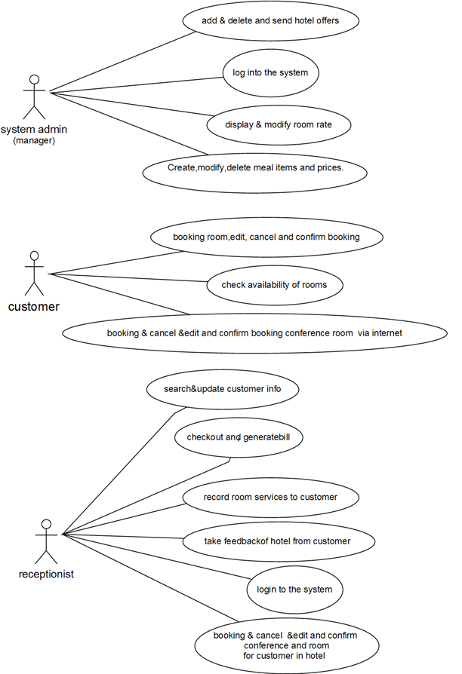

**sequence diagrams:-**

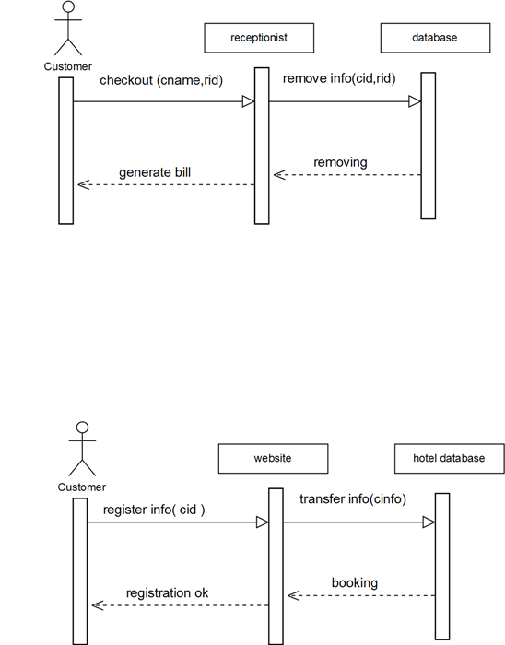

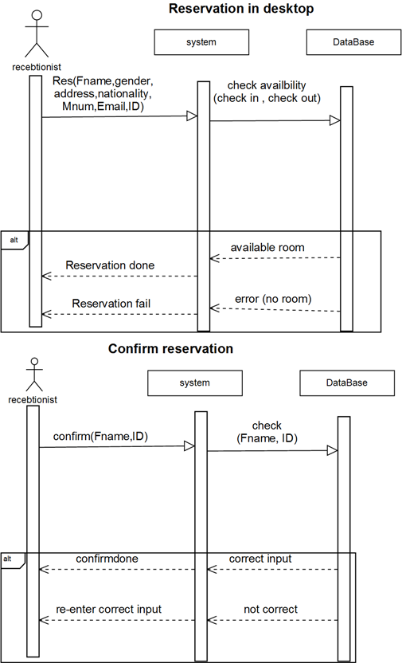

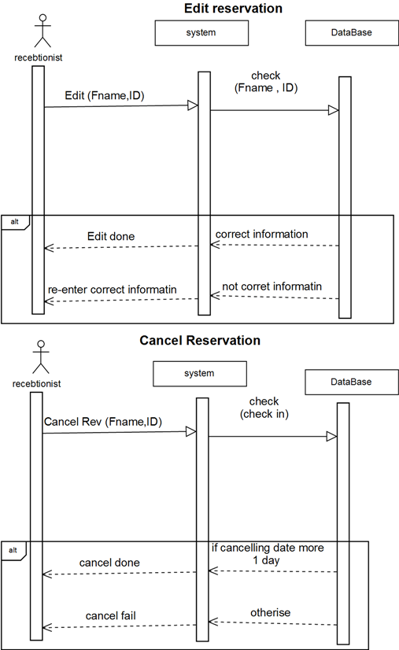

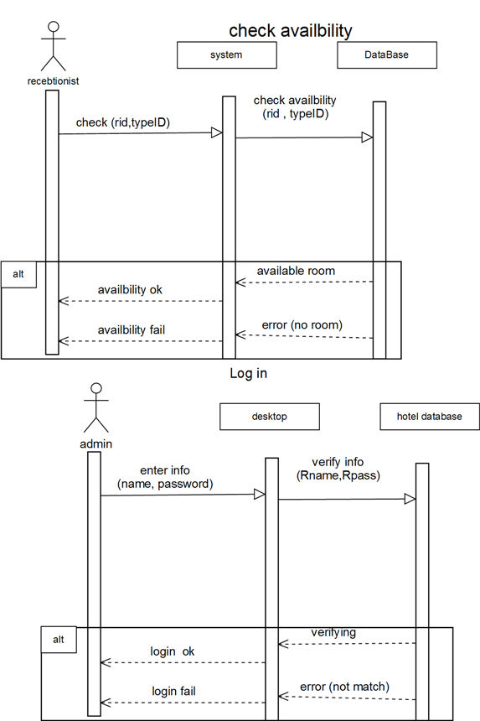

**Activity diagrams:-**

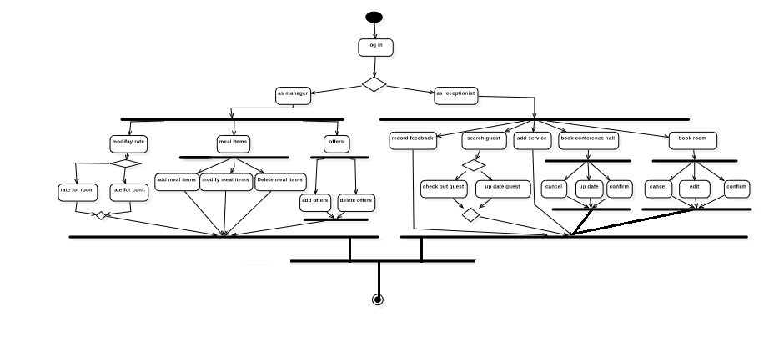

**Class diagrams:-**

Untitled Diagram (2)

**state diagrams:-**

